**Objects Containing Objects**

Create a Java program that imitates a pantry containing three jars of jam. The program should contain three classes: Jam, Pantry and PantryTester (which consists of the main method).

1. The Jam class.

a. Create all the necessary fields for the class. Each Jam object should keep track the following information:

• Content (what type of fruit it is)

• Date (when it was canned)

• Size (number of oz in the jar)

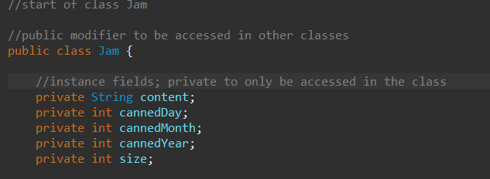

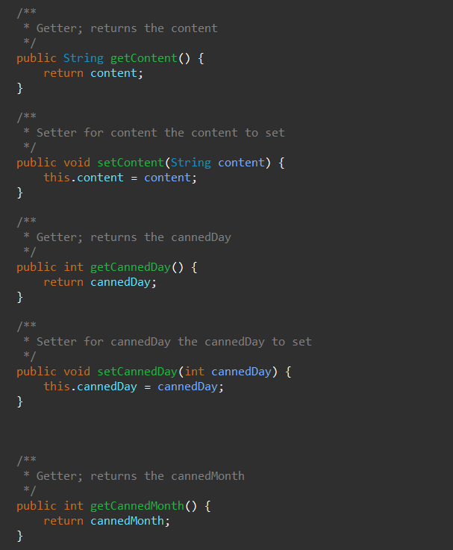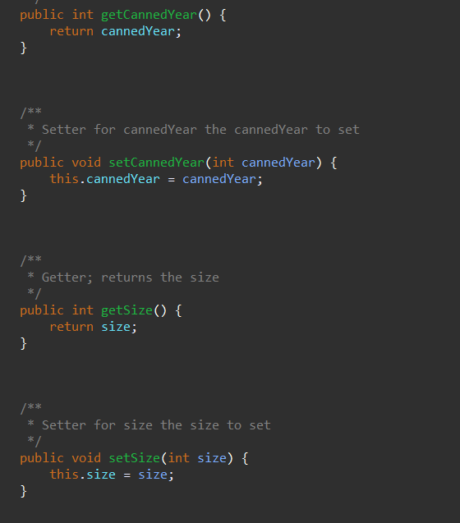

b. Create all the necessary methods. Each Jam object should perform the following tasks:

• Check if the jar is empty

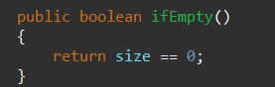

• Remove some jam (spread an amount on toast) - if the user wants to spread more jam than is available, spread only the

amount that is left in the jar – output a message indicate the

amount of jar that was spread

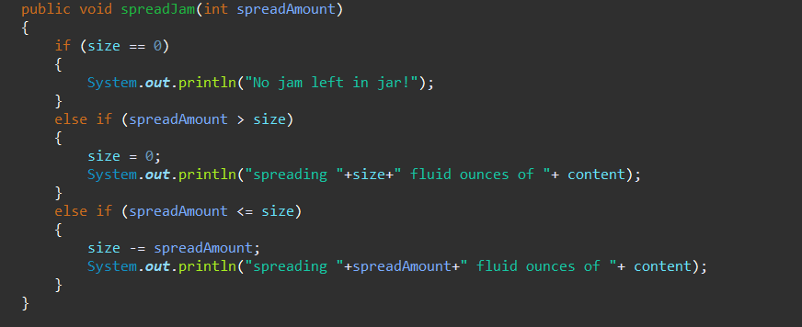

OR

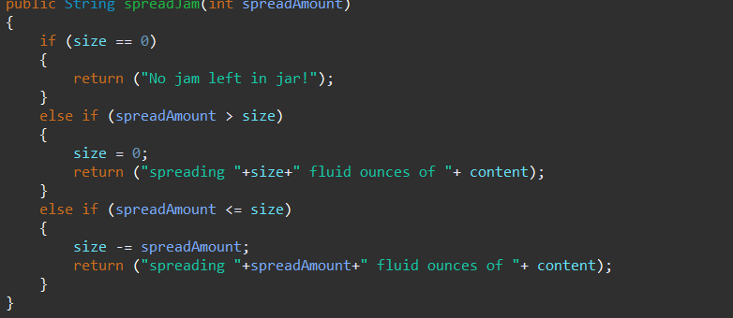

• Allows the capability to print info about the jar



c. Create a constructor that initializes the instance variables of the object being constructed.

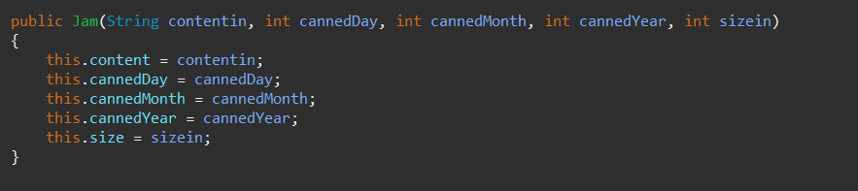

2. The Pantry class:

a. A pantry consists of three jars of jam. Create the instance fields accordingly.

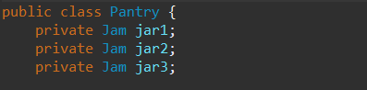

b. Create the methods that perform the following tasks:

• To spread jam from the selected jar

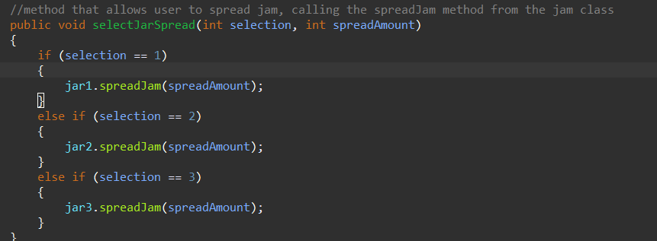

• Allows the capability to print the content of the pantry (each of the three jars in the pantry)

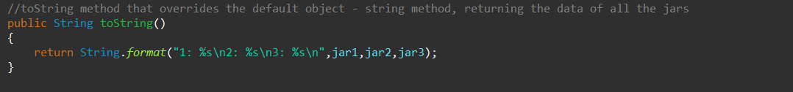

c. Create a constructor that takes three object reference parameters. The three objects will be the three jars to be kept in the pantry. The object must already exist before using this constructor.

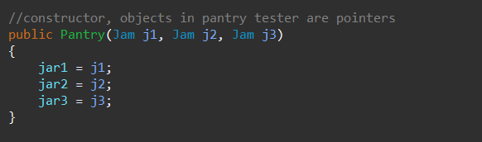

3. Create a PantryTester class that performs the following: a. List the available jams. & b. Prompt the user.

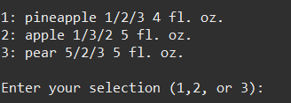

c. Input the users selection.

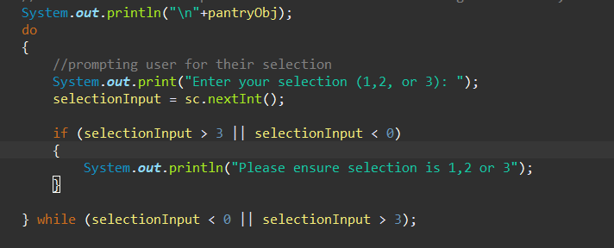

d. Write an error message for an out-of-range selection (and then start over).

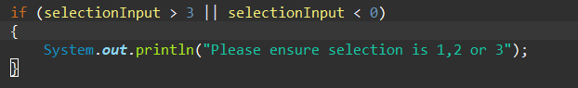

e. Prompt the user for an amount.

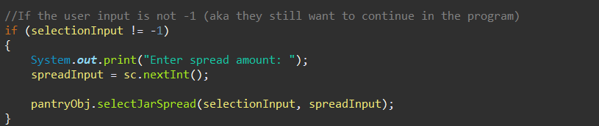

f. Decrease the amount of the selected jam by the proper amount.



g. Exit when the user selects jam -1, otherwise start over.

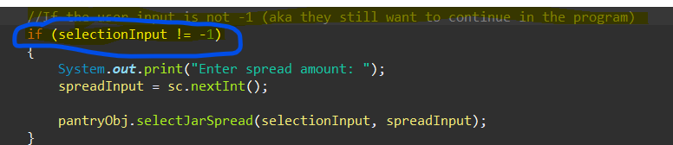



Sample Output:

Welcome to Mother Hubbard's Pantry!

The jams are:

1: Gooseberry 7/4/86 12 fl. oz. 2: Crab Apple 9/30/99 8 fl. oz. 3: Rhubarb 10/31/99 16 fl. oz. Enter your selection (1, 2, or 3): 1

Enter amount to spread:

2

Spreading 2 fluid ounces of Gooseberry

The jams are:

1: Gooseberry 7/4/86 10 fl. oz. 2: Crab Apple 9/30/99 8 fl. oz. 3: Rhubarb 10/31/99 16 fl. oz. Enter your selection (1, 2, or 3): 2

Enter amount to spread:

25

Spreading 8 fluid ounces of Crab Apple

The jams are:

1: Gooseberry 7/4/86 10 fl. oz. 2: Crab Apple 9/30/99 0 fl. oz. 3: Rhubarb 10/31/99 16 fl. oz. Enter your selection (1, 2, or 3): 2

Enter amount to spread:

9

No jam in the Jar!

The jams are:

1: Gooseberry 7/4/86 10 fl. oz. 2: Crab Apple 9/30/99 0 fl. oz. 3: Rhubarb 10/31/99 16 fl. oz. Enter your selection (1, 2, or 3): -1

Good-by